## Electronic Launch Operations Control

### Introduction

In order to safely control the rocket before and through launch, an electronic control system was designed that will allow the operator to remotely send commands to and return live data from the rocket while it is on the ground. The IREC Advanced Category rule 7.2.2.1 requires all personnel to be 400 feet away, but the system must be capable of operating over a minimum safe distance of 2500 feet for testing, as specified in the Tripoli Rocketry Association Safe Launch Practices Distance Table. Arming and disarming the launch circuitry is required by IREC Advanced Category rule 3.4 and 7.2.2.2 such that the controller cannot provide any ignition signal to the rocket without first being armed. At minimum, the controls must allow filling and venting of the onboard nitrous tank, filling the combustion chamber with oxygen for starting, the actuation of a pneumatic quick disconnect valve to separate the fill line, signaling an onboard valve to open and start nitrous flow, and an igniter. To correctly fill the onboard nitrous tank with the correct amount of nitrous, pressure, temperature, and load cell data will be streamed back live to the operator. The state of the quick disconnect line must be monitored to ensure it separates prior to launch. The launch control system must be in constant, reliable, and bandwidth-capable communication with the operator’s station. This year, more focus has been placed on creating a new modular, expandable control system that will continue to meet the needs of future SRT teams, not require both AC and DC power to operate (as SRT-2’s did), and provide the safest possible control mechanisms.

### Launch Relay System

The Launch Relay System is the critical piece of launch hardware designed to meet these goals for SRT-3, and will offer more modularity and reliability than the previous launch controller. Initially, wired control was desired for the Launch Relay System to eliminate the wireless communication anomalies experienced last year, but the 2500 feet safety range required by Tripoli made this option prohibitively expensive. Category 6, BNC, serial, and USB connectors all work only under a range of about 300 feet. Category 6 cable alone is rated for lengths up to 328 feet, so an Ethernet extender must be used at both ends to give 2500 feet of range. Two appropriately sized extenders and 2000 feet of Category 6 cable would total $1970.98. A wireless system built using long-range xbee modules and external antennas can provide a much more streamlined solution with a 9 mile range for only ~$200 (discussed in detail in section ). This wireless system has been successfully demonstrated and will meet the communication requirements of the Launch Relay System.

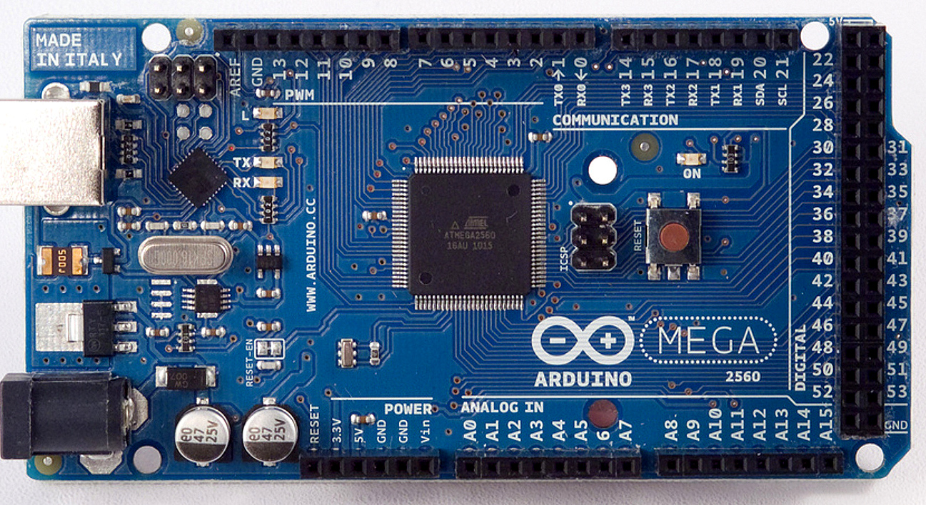

Figure Error! No text of specified style in document..1. Arduino Mega 2560 R3 Microcontroller

The Launch Relay System is based around the simple and reliable Arduino microcontroller boards. The Arduino Mega 2560 R3 () was chosen because of its native IO capabilities (54 digital inputs/outputs, 16 analog inputs, 4 serial connections). This board leaves plenty of channels for future expansion, and provides a simple programming atmosphere that works well with xbee.

Helium gas is typically required in the filling process to pressurize the oxidizer tank. Though SRT-3 will not use this technique, the launch box must be designed to power helium solenoids so that an extensive overhaul is not required next year. All current solenoids that are capable of handling 2000-2500 psi helium and likely be within the budget of future SRT teams require either 24 VDC or 120+ VAC to operate. The cost of replacing all of SRT's 12 VDC valves with 120 VAC solenoids is more expensive than buying 2 DC solenoids. When required, the two AC helium solenoids from the SRT-2 control system will be replaced with two valves similar to the Extreme-Pressure Stainless Steel Solenoid Valve (McMaster-1190N23), which operates at 24 VDC and withstands up to 3000 psi. The Launch Relay System was designed to operate in mixed 12 and 24 VDC, single battery 12 VDC, and dual battery 12 VDC modes with only a minute of rewiring required to change between modes. This solution required 2 car batteries like the previous controller, allowed almost all of last year's solenoids to be reused, and did not require a generator to power AC components.

A 15.74 in by 11.81 in by 6.29 in ABS plastic hinged electronics box was chosen to be the physical container because it can be easily cut to add interface features, and had enough space to support upgrades. An internal steel panel supports the stainless steel DIN 3 rails used to mount relay sockets and screw terminal blocks. Twelve 20 A wall outlets used to connect the solenoids will be mounted through holes on one side of the box and labeled with numbers. These match the new 12 VDC solenoid refit scheme at Riverside Test Stand where valve open goes to hot, valve close (if used) goes to neutral, and (load carrying) ground goes to ground. These plugs prevent 12 VDC solenoids from being plugged into standard 15 A AC wall outlets, and are easier to purchase and less expensive than Twist-Lock connectors. The top of the box has 2 power switches, 2 arming controls, and an igniter continuity tester, as well as indicator LEDs for each switch (Figure a).

The relay control circuit diagram in the Launch Relay System is shown in . It should be noted that the circuit shown is the mixed 12 and 24 VDC mode because it had the most use for future SRT teams, though no 24 V components are required this year. The Arduino controller is powered by two separate 9V batteries in parallel, so that failure of either car battery will not disable the controller. TE Connectivity 1887112-3 SPDT relays were used to switch the solenoids because they are rated to 16 A, have a 12 VDC coil, and have internal flyback diodes and test LEDs, for less than the cost of solid state relays. The box uses twelve total of these relays: nine 12 VDC channels, two 24 VDC channels, and a 12 VDC igniter relay control channel. These were selected in favor of auto relays because of the difficulties experienced with finding secure auto relay sockets for the Riverside Test Stand. Three 5-packs of N-Channel SLA5085 common-source MOSFETs rated at 60 V, 10 A () switch the ground of the relays to activate individual channels, and incorporate standard 10K Ω pull-down and 100 Ω safety resistors to protect the Arduino and transistor. Each package can dissipate 5 W without a heat sink but would only experience 2.5 W maximum if all relays were energized. To provide 24V for the two potential helium solenoids, a second car battery is connected in series, and this system could easily power more 24V devices, if needed. A traditional pyrotechnic igniter is powered by the large Monster Relay reused from SRT-2 that can handle 100 A and has a 12 V coil that is controlled by another relay (for arming safety purposes). In mixed 12 and 24 VDC mode, the launch box operates the igniter with 24 V to reduce the load on each individual battery.

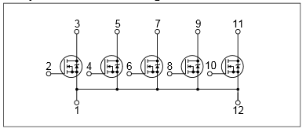

Figure Error! No text of specified style in document..2. 5x N-Ch. MOSFET SLA5085

shows an itemized breakdown of the components needed to upgrade the control channels on the Launch Relay System.

Table 1.2 Itemized Cost Breakdown of Launch Box Components

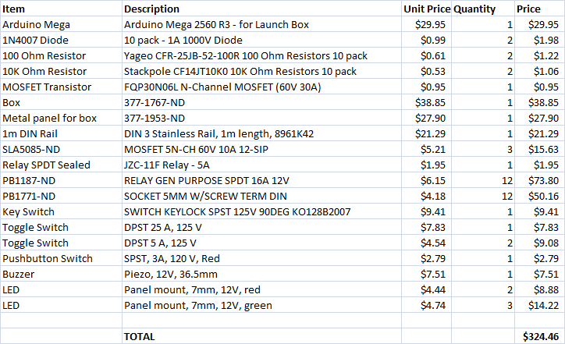

In addition to the MOSFET relay drivers, the rocket's computer must also be connected to the launch box by wire to access sensor data during filling and give the command to start the flow of oxidizer. This reuses internal sensors but allows the data to be transferred back to the control station in real time.

Safety was a key design factor of the Launch Relay System. A combination manual lockouts and remote arming mechanisms (activated by the Arduino) will prevent all foreseeable risks and provide a manual override in the event of an unforeseen hazard. The computer circuit is switched on before the solenoid power to prevent any problems with logic outputs initializing high and making the MOSFETs float. System arming is achieved by a small 5 A relay that switches the (+) side of every other relay to +12V when armed remotely commanded, but a key switch on the box must be turned before this relay can switch. Once this relay energized, the system is considered active, and a buzzer on the box sounds to warn anyone close. This buzzer should never actually be heard because the area around the launch site should be cleared prior to activating the system. The igniter relay control has additional safety systems in place alongside the previous ones. A toggle switch on the launch box provides manual override to specifically disable the igniter, and the Arduino must signal both an igniter arming and igniter firing circuit to energize the igniter relay. To check the continuity of the igniter, a 12 V LED package was chosen that will pass 20 mA through the ignition circuit when a button is held on the launch box. The steps of the arming process are explicitly listed below and have the relevant control marked with the step number on Figure a.

Arming Sequence:

1. Connect batteries
2. Power on computer
3. Power on solenoids
4. Test igniter continuity
5. Enable igniter circuit
6. Arm with the key switch
7. *Move personnel to safe distance*
8. Wirelessly activate arming relay (buzzer sounds)
9. Oxidizer fill sequence
10. Wirelessly arm igniter relay
11. Ignition
12. Disarm in reverse

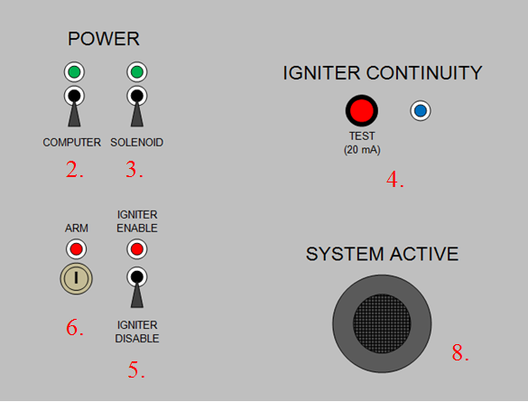

Figure . Launch Box Interface Panel (Figure a)

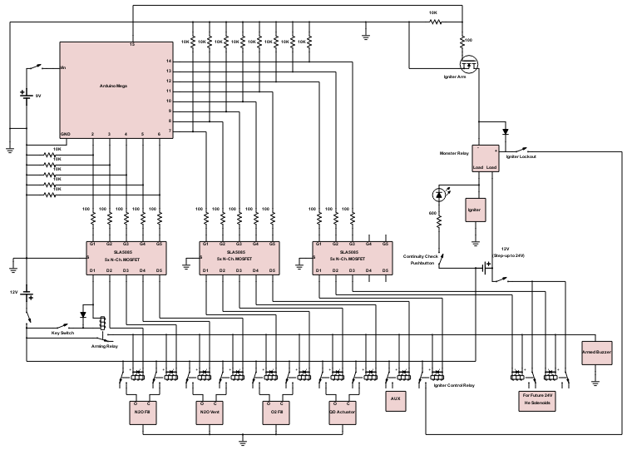

Figure 1.4 Launch Relay System Schematic